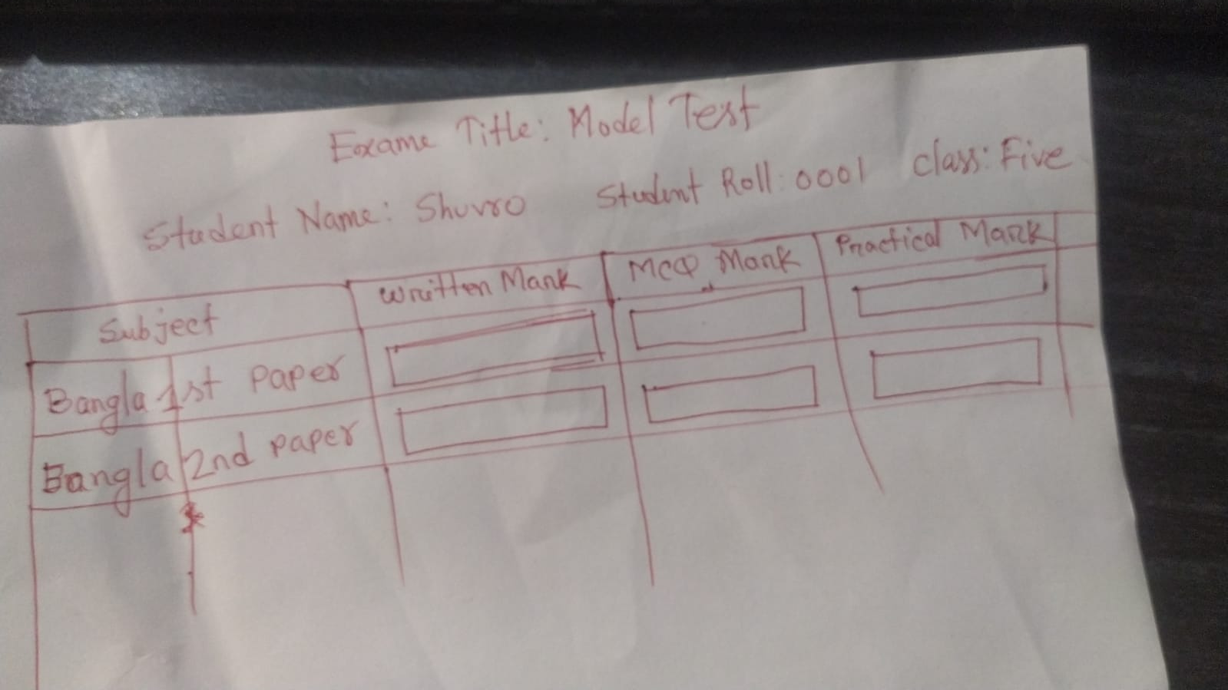

**Model name: school_management.grade_config**

* name
* min_mark
* max_mark
* point

**Model name: school_management.proccessed_result**

* exam
* student
* subject
* grade_point
* total_mark
* grade_title

**Model name: school_management.class_config**

* name

**Model name: school_management.student**

* name
* code(compute, store=True)
* roll
* blood_group (Selection)
* guardian (portal user)(Many2one)
* class (Many2one) -> class_config

**Model Name:** **school_management.subject**

* name
* has_practical
* has_mcq
* has_written

*Data will be inserted vaia wizard*

**Model Name:** **school_management.subject_config**

* class:many2one
* subject: many2many

**Model Name:** **school_management.result_config**

* subject (many2one)
* written_pass_mark
* written_max_mark
* mcq_pass_mark
* mcq_max_mark
* practical_pass_mark
* practical_max_mark

**Model Name:** **school_management.exam**

* name
* status (pending, processing, taken)

*NOTE: only one exam must be in processing state. And it will be set by admin. When teacher will put mark then it will be automatically tagged to exam with ‘processing’ state*

**Model Name:** **school_management.result**

* exam (many2One) compute
* subject (many2One)
* written_mark
* mcq_mark
* practical_mark

*Result input portal theke hote hobe*